

Make default country by registered native language

By Boren

내용

1. Requirement history 2

2. Requirements Purpose 3

3. Requirements List 3

# Requirement history

|  |  |  |  |  |
| --- | --- | --- | --- | --- |
| Version | Date | Author | Type | Contents |
|  | 2021-10-15 |  | Select country for a new recipient | When creating a new recipient, for payout country should make it as default by registered Native country rather than allow customer to select or search country by themselves. |
|  |  |  |  |  |

# Requirements Purpose

Purpose of this requirement is that in current method, when customer create a new recipient, they must select a country for payout. And in our current App the country name is Short by A-Z. For Cambodia is start from letter C. that’s mean we must scroll down from A-Z to search for a country we want to choose. So for this purpose I want remove “Select Payout Country” step by put Registered native country for a default payout country.

# Requirements List

1. Make Registered Native country as Default country.

**Mobile Application**

**View on App when create new recipient**

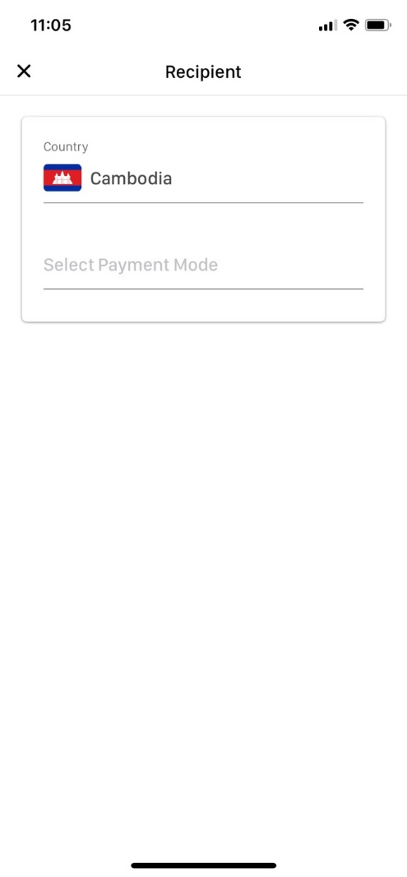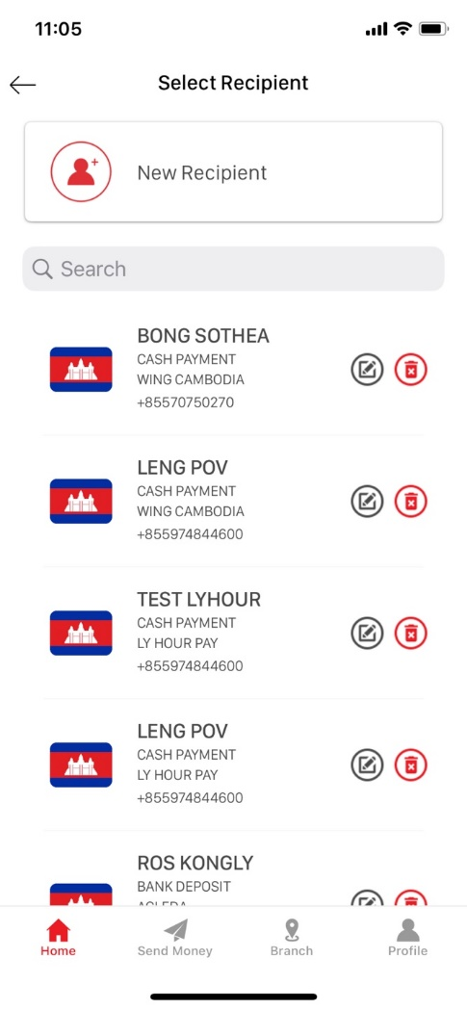

Native Country